**Steps to generate the First set of .java files for a pattern:**

1)Once gradlew runIde is executed in the terminal, the below window will open.

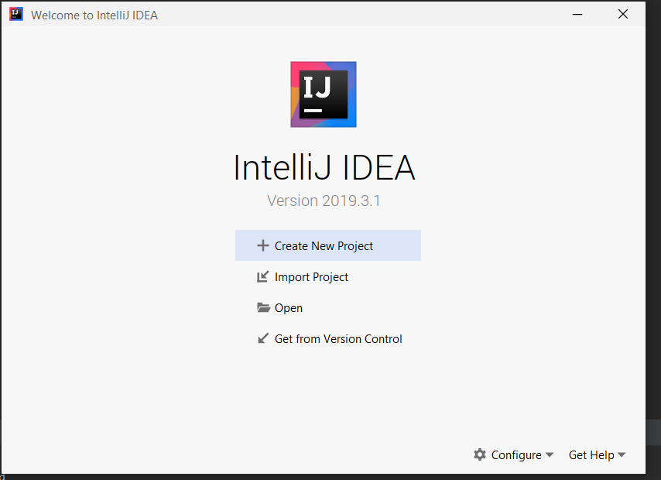

2) Click on create a project and create a Java Project with name “Test” (or name that is preferred).



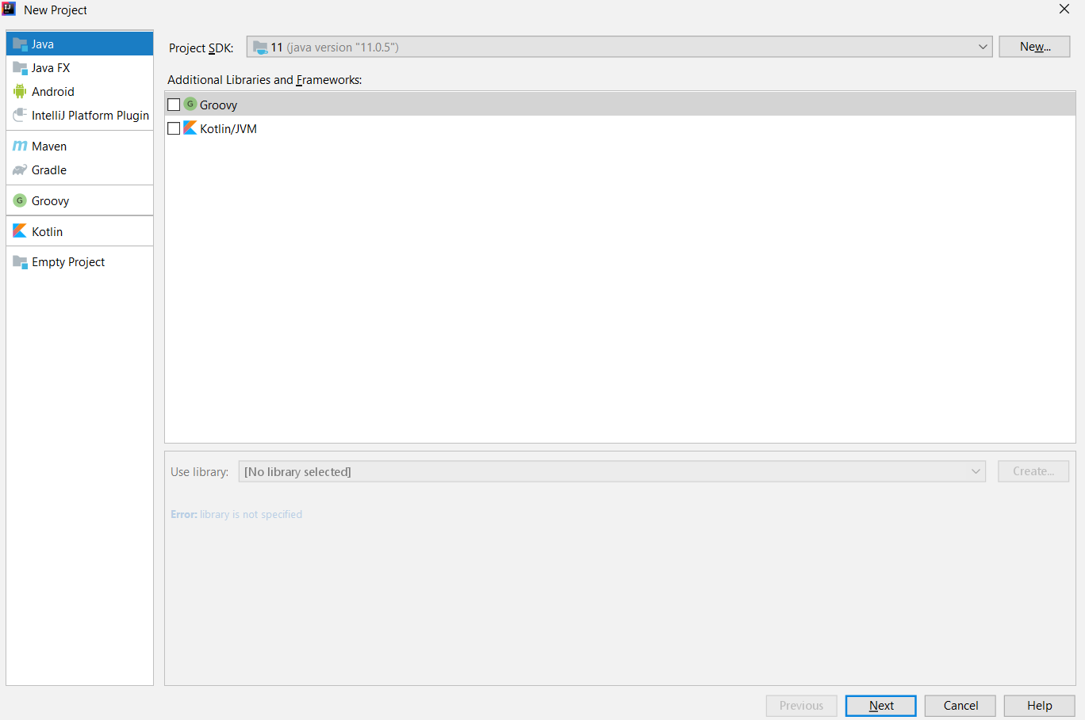

Click next and again click next:

3) Create a project with name “Test” and click finish:

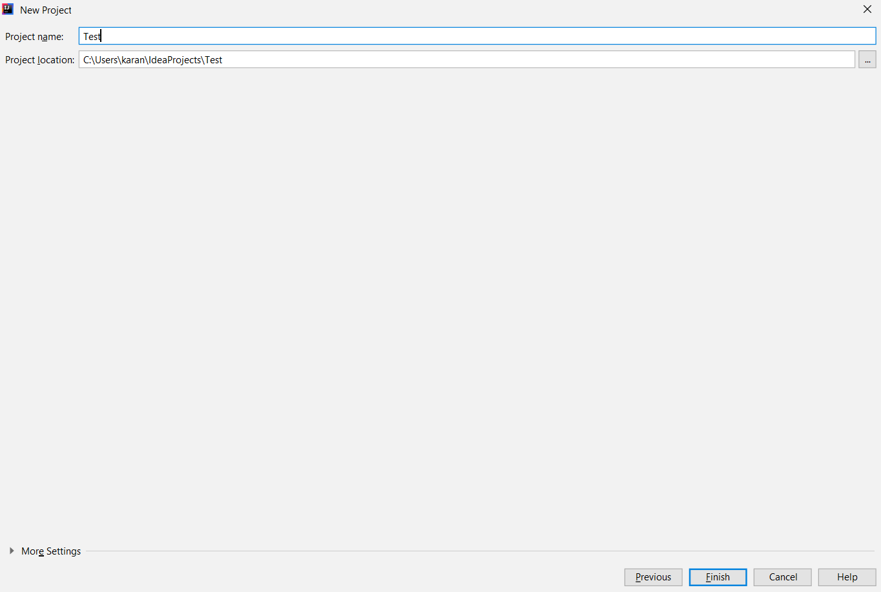

4) Click on the Pattern Generator button in the bottom-right side of the window, which will open a dockable window containing radio button for each pattern that the user wants to generate. In below set of images, the user is selecting Bridge pattern and clicking on submit button.

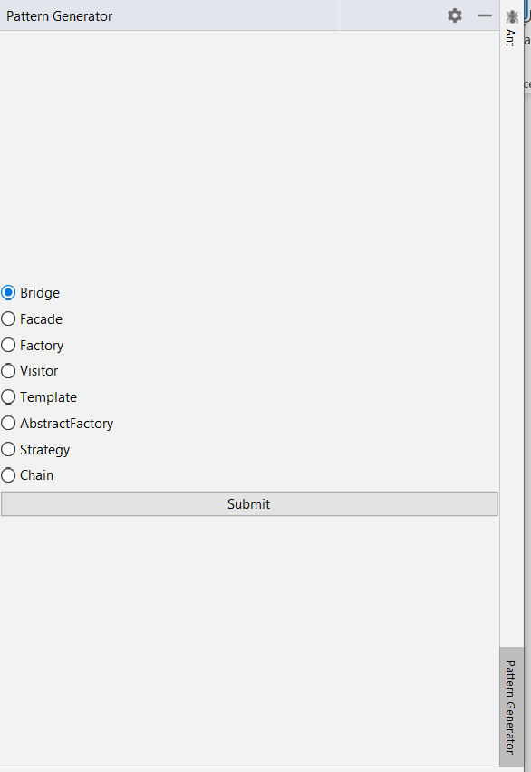

5) After clicking the submit button a dialogue window will open prompting for user inputs. (Note: All the text fields should be filled, if any one of the text fields are empty a warning pop will appear staying to fill all the fields). After clicking all the fields click on ok.

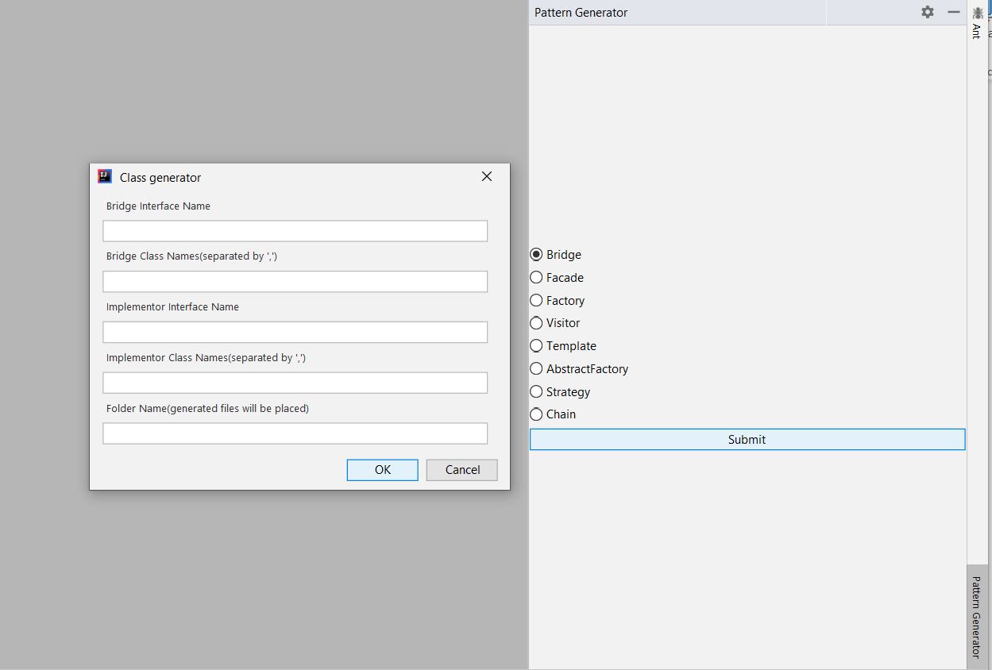

(Note: Some of the fields are multivalued field, please give it in comma separated format)

Look at the below filled template for bridge pattern and the last field for every pattern is the folder under which the .java files will get generated under project_path/src/folder_name_given_in_textbox)

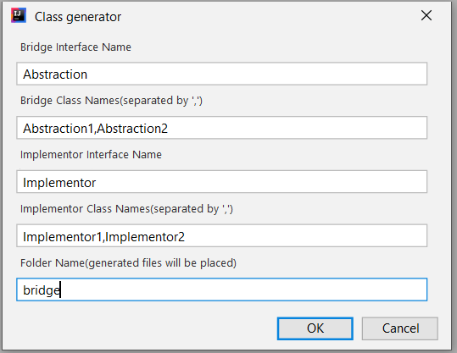

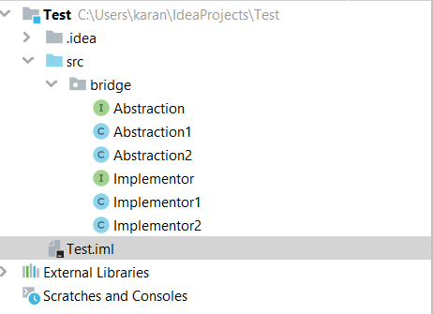

**Steps to test name clash for single module(Test) and bridge package scope:**

1)In the opened dockable window containing radio buttons for each pattern that the user wants to generate. Click on Bridge pattern and click Submit.

It will open a dialog box for user inputs, fill all the inputs according to the below image:



Click on Ok. You will get the below name clash error message with all the Types that have been part of the Clash.

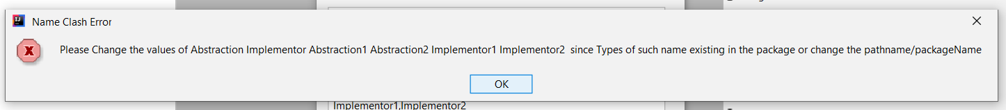

The User can take two different steps to avoid the above message.

1. By changing the names of all the Types so the name clash does not occur.(Folder will be bridge only)

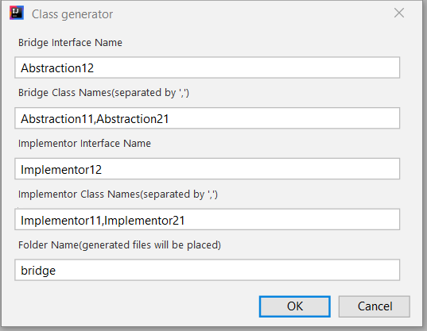

1. Or the user can just change the folder name that is to bridge1(which will change the package scope)

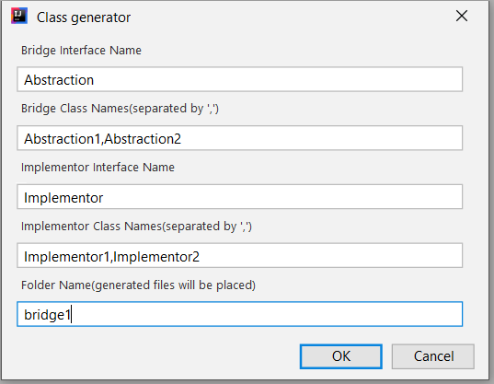

**Steps to test name clash for Multi module(Test and Sub) and bridge package scope:**

1)First create new module sub under Test Module:

Right click on Test Folder and create a new module:

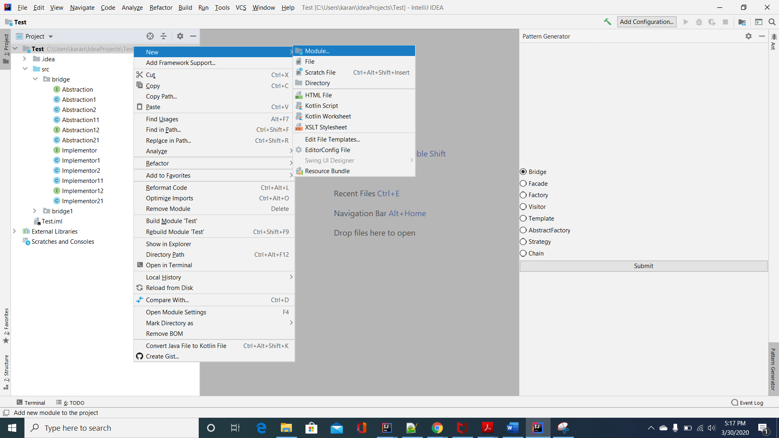

Click on next:

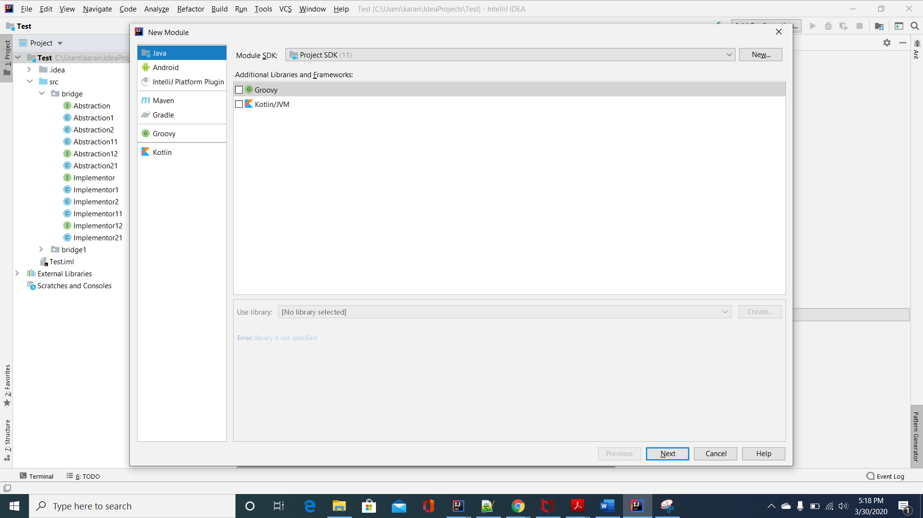

Name the new Module Sub and click on ‘Finish’:

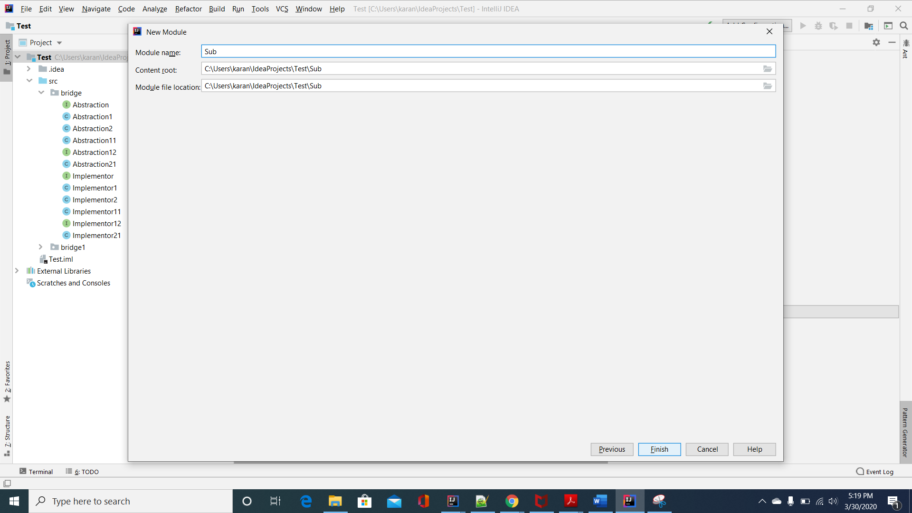

Now the move bridge Folder from Test/src/ to Sub/src: (don’t copy but move the folder bridge)

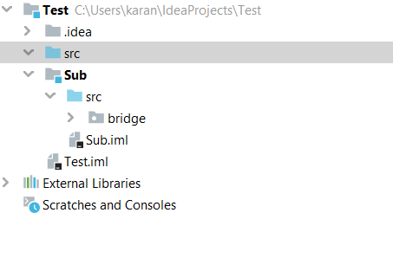

In the opened dockable window containing radio buttons for each pattern that the user wants to generate. Click on Bridge pattern and click Submit.

It will open a dialog box for user inputs, fill all the inputs according to the below image:



Click on Ok.

This time you won’t get the error message because even though the package name(bridge) is same in both the modules the module scope is different.

